**DAILY ONLINE ACTIVITIES SUMMARY**

|  |  |  |  |  |  |  |  |  |
| --- | --- | --- | --- | --- | --- | --- | --- | --- |
| **Date:** | **19-06-2020** | | | | | **Name:** | **Pallavi** | |
| **Sem & Sec** | **6th - A** | | | | | **USN:** | **4AL17CS056** | |
| **Online Test Summary** | | | | | | | | |
| **Subject** | | **1.Programming in C** 2.Applications of Python Programming in DA and ML | | | | | | |
| **Max. Marks** | | **-** | | **Score** | | | **-** | |
| **Certification Course Summary** | | | | | | | | |
| **Course** | Workshop on “Applications of Python Programming in DA and ML” | | | | | | | |
| **Certificate Provider** | | | **-** | | **Duration** | | | **-** |
| **Coding Challenges** | | | | | | | | |
| **Problem Statement:1 Python program** | | | | | | | | |
| **Status: executed** | | | | | | | | |
| **Uploaded the report in GitHub** | | | | | **Yes** | | | |
| **If yes Repository name** | | | | | <https://github.com/pallavi056/DAILY_STATUS> | | | |
| **Uploaded the report in slack** | | | | | **Yes** | | | |

Online Test Details: (Attach the snapshot and briefly write the report for the same)

Programming in C

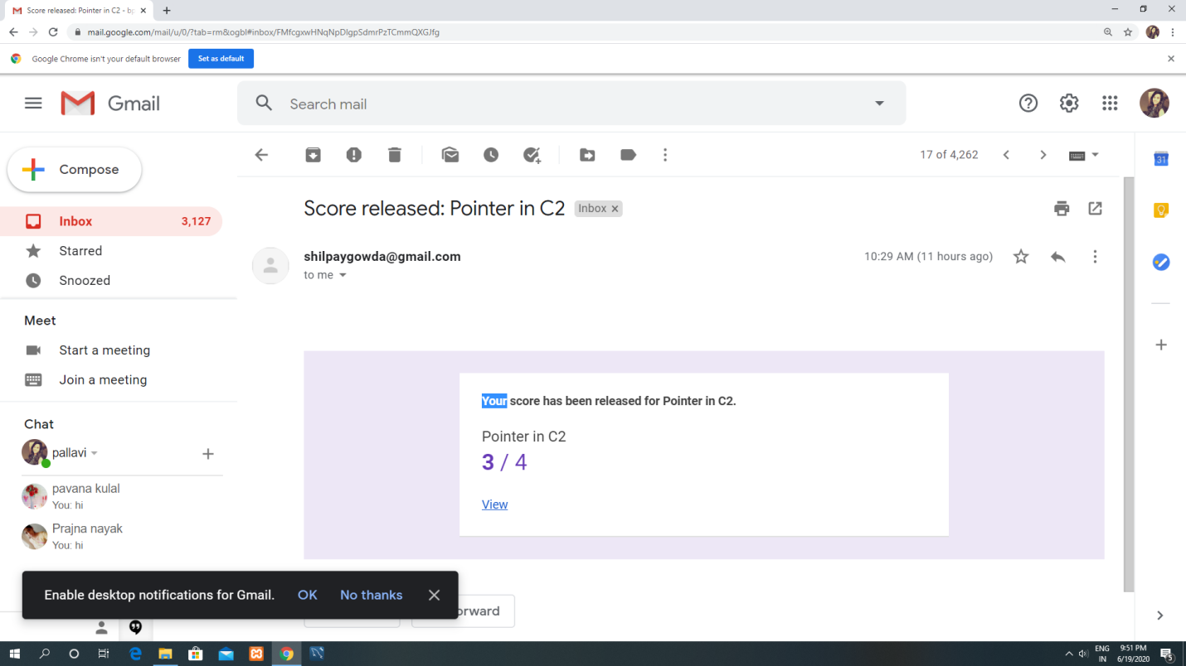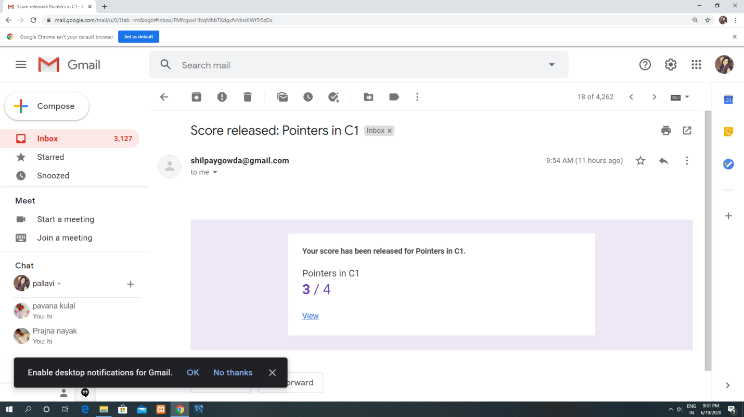

Certification Course Details: (Attach the snapshot and briefly write the report for the same)

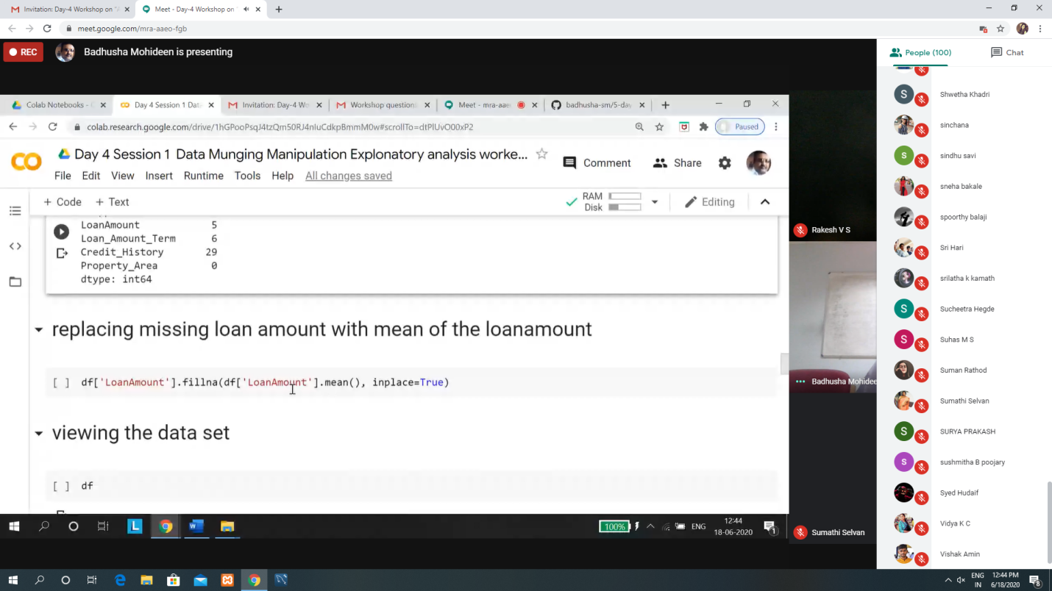

Coding Challenges Details: (Attach the snapshot and briefly write the report for the same)

### Workshop on “Applications of Python Programming in DA and ML”

Today’s exercise uploaded in :-<https://github.com/pallavi056/application-of-programing-in-DA-in-DA-ML>

Online coding:-

[https://github.com/pallavi056/DAILY_STATUS/tree/master/19-6-2020/ONLINE%20CODING](https://github.com/pallavi056/DAILY_STATUS/tree/master/19-6-2020/ONLINE CODING)